Power BI Custom Visual Step by Step

Step 2 Code Editor

<1> In this tutorial I used Visual Studio, which can be downloaded from:

https://www.visualstudio.com/thank-you-downloading-visual-studio/?sku=Community&rel=15

<2> Click Open, and select filder MyCustomVisual

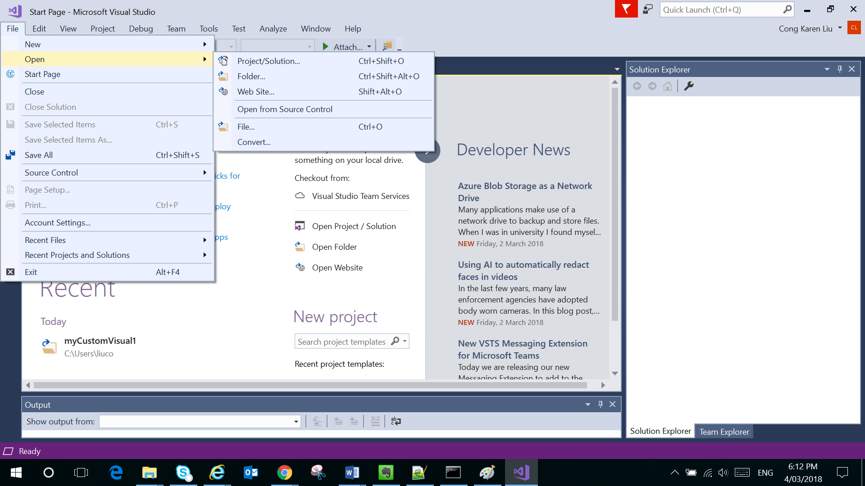

Then we can see the files created for custom visual

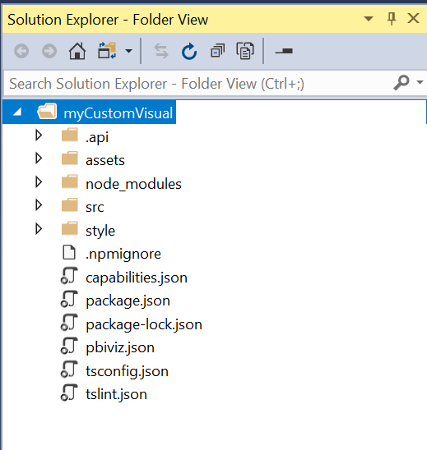

<3> Visual.ts

This is the main file for custom visual.

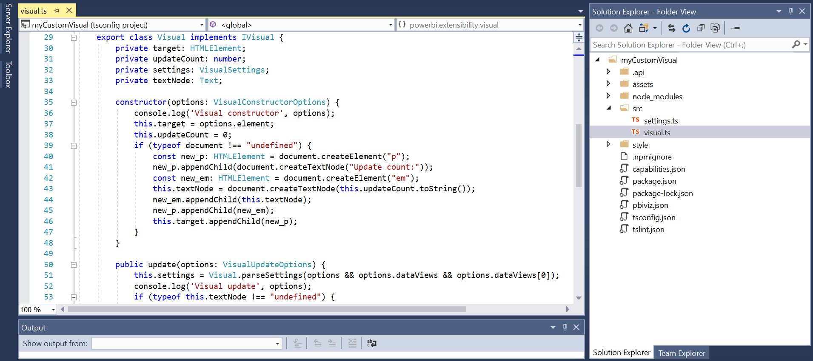

We can make some changes to see how it works.

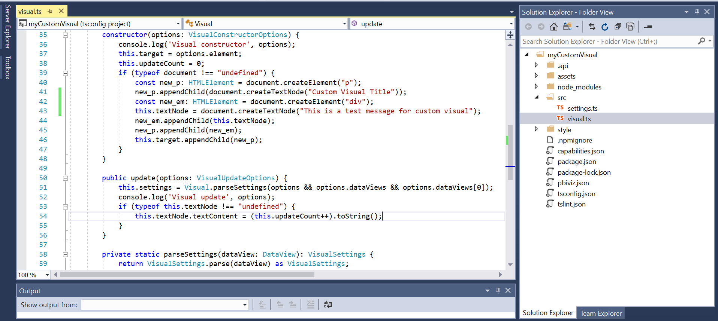

Then we wait for the code to rebuild.

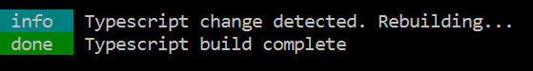

And go back to Power BI and refresh the report.

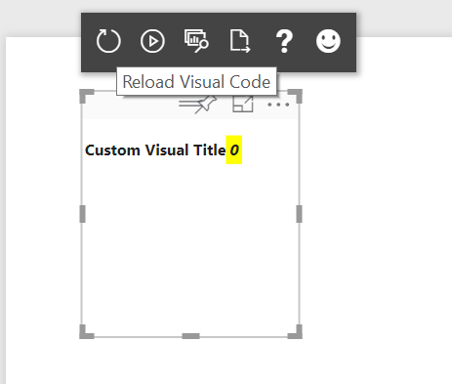

Then we can see the changes we made reflected.

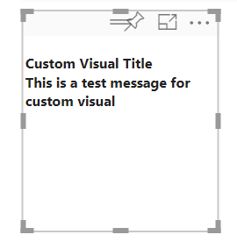

<4> Terminating the server

Ctrl + c can stop the server

